The Corporation of the
Municipality of Powassan

Re: Minor Variance to seek relief from provisions of the Zoning By-law 2003-38 in accordance with Section 45(1) of the Planning Act
File #: 2022-03
Applicant: Braden Nickerson

Location of Property: Part Lot 13, Concession 15, RP PSR 1386, 124 Lindquist Line (Refer to key map)

Present Status of Land Subject to Application: Lands are developed with an existing dwelling and two accessory buildings.

Purpose and Effect of the Application: The Applicant is requesting relief from Section 4.4.2(iii) of Zoning By-law 2003-38 being the minimum front yard setback of 30 metres in the Rural (RU) zone. The Application is proposing to construct a 9.7 sq m covered entry at the front of the existing dwelling with a setback of 11.7 metres from the front lot line. The variance requested is 18.3 metres. The existing dwelling is located approximately 14.0 metres from the front property line.

Additional Information: If you require additional information or have any questions with respect to this application please contact Ms. Kimberly Bester, Secretary-Treasurer at 705-724-2813.

TAKE NOTICE THAT an application under the above file number will be heard by the Committee of Adjustment on the date and time and place shown below, under the authority of Section 45 of the Planning Act.

APRIL 20, 2022 – 6:15 PM
MUNICIPALITY OF POWASSAN
250 MAIN CLARK ST., POWASSAN ONTARIO

PUBLIC HEARING: You are entitled to attend this hearing in person or you may be represented by Counsel or an Agent to give evidence about the application. Signed, written submissions that relate to this application shall be accepted by the Secretary-Treasurer before or during the hearing of the application at the address above and shall be available to any interested person for inspection prior to or at the hearing.

FAILURE TO ATTEND: If you do not attend at this Public Hearing, it may proceed in your absence and except otherwise provided in the Planning Act, you will not be entitled to any further notice in the proceedings.

IF A PERSON or public body does not make written or oral submissions to the Municipality of Powassan before the proposed applications are approved, the person or public body is not entitled to appeal the decision of the Municipality of Powassan to the Ontario Land Tribunal.

IF A PERSON or public body does not make written submissions to the Municipality of Powassan before the proposed applications are approved, the person or public body may not be added as a party to the hearing of an appeal before the Ontario Land Tribunal unless, in the opinion of the Tribunal, there are reasonable grounds to do so.

NOTICE OF DECISION: A certified copy of the decision, together with a notice of the last day of appealing to the Ontario Land Tribunal shall be sent, no later than 10 days from the making of the decision, to the applicant, and to each person who appeared in person or by counsel at the hearing and who filed a request for notice of the decision.

Dated this 8th day of April
Ms. Kimberly Bester, Secretary-Treasurer
Powassan Committee of Adjustment
Box 250, Powassan ON P0H 1Z0

KEY MAP

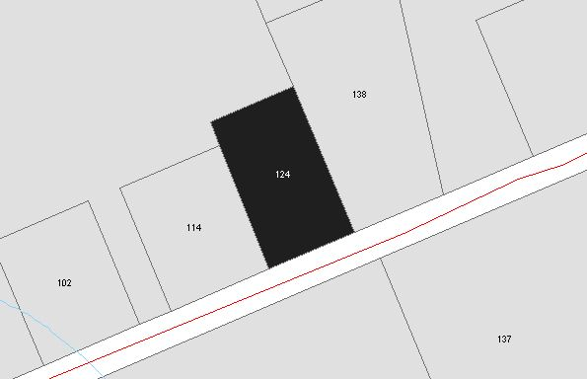

SITE PLAN (PROVIDED BY APPLICANT)

